**ASSIGNMENT 10 – W3D2 – LESSON11 –MongoDB Operations and Aggregation:**

**Using your Database named, MyLibraryBooks-DB, from Lab Assignment 9, perform the following:**

1. **Write and execute code to perform the following data updates/changes to the data in the Collection named, booksCollection:**
   1. **Change the Publisher of the book whose ISBN is “ISBN-000-234” from “First Head” to “McGraw-Hill”.**

db.booksCollection.updateOne({"ISBN":"ISBN-000-234"},{$set:{"Publisher":"McGraw-Hill"}})

{ "acknowledged" : true, "matchedCount" : 1, "modifiedCount" : 1 }

* 1. **Also make the following updates to the Publisher names for the Books listed in the table below:**



|  |  |  |  |
| --- | --- | --- | --- |
| **#** | **ISBN** | **Book Title** | **Publisher** |
| **1** | **1234534** | **Dagmay Fetene** | **McGraw-Hill** |
| **2** | **012345** | **Design patterns** | **Pearson** |
| **3** | **21312423535** | **Godfather** | **Longman** |
| **4** | **978-0135974488** | **Hacker Cookbook** | **Apress** |
| **5** | **1234-121210** | **Harry Potter** | **McGraw-Hill** |

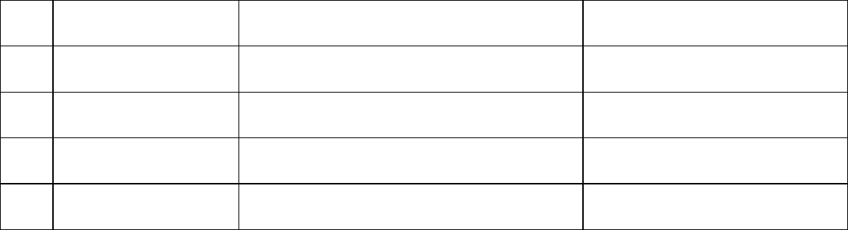

db.booksCollection.updateOne({$or:[{"ISBN":"1234534"},{"Title":"Design patterns"}]},{$set:{"Publisher":"Pearson"}})

{ "acknowledged" : true, "matchedCount" : 1, "modifiedCount" : 1 }

db.booksCollection.updateOne({$or:[{"ISBN":"21312423535"},{"Title":"Godfather"}]},{$set:{"Publisher":"Longman"}})

{ "acknowledged" : true, "matchedCount" : 1, "modifiedCount" : 1 }

db.booksCollection.updateOne({$or:[{"ISBN":"978-0135974488"},{"Title":"Hacker Cookbook"}]},{$set:{"Publisher":"Apress"}})

{ "acknowledged" : true, "matchedCount" : 1, "modifiedCount" : 1 }

db.booksCollection.updateOne({$or:[{"ISBN":"1234-121210"},{"Title":"Harry Potter"}]},{$set:{"Publisher":"McGraw-Hill"}})

{ "acknowledged" : true, "matchedCount" : 1, "modifiedCount" : 1 }

1. **Write and execute code to return a collection of all the Publishers in the booksCollection and for each Publisher, compute and include the Number of Books they have published.**

db.booksCollection.aggregate([ {$group:{_id:"$Publisher",num_publication:{$sum:1}}},

{$project:{_id:0,Publisher:"$_id",num_publication:1}}

])

{ "num_publication" : 2, "Publisher" : "Longman" }

{ "num_publication" : 1, "Publisher" : "Apress" }

{ "num_publication" : 1, "Publisher" : "Stanley B. Lipmann" }

{ "num_publication" : 3, "Publisher" : "McGraw-Hill" }

{ "num_publication" : 1, "Publisher" : "Publisher1" }

{ "num_publication" : 2, "Publisher" : "Pearson" }

Alternatively.

db.booksCollection.aggregate([{$group:{_id:"$Publisher",count:{$sum:1}}}, {$project:{_id:0,Publisher:"$_id",num_publication:"$count"}} ])

{ "Publisher" : "Pearson", "num_publication" : 2 }

{ "Publisher" : "Longman", "num_publication" : 2 }

{ "Publisher" : "Apress", "num_publication" : 1 }

{ "Publisher" : "McGraw-Hill", "num_publication" : 3 }

{ "Publisher" : "Stanley B. Lipmann", "num_publication" : 1 }

{ "Publisher" : "Publisher1", "num_publication" : 1 }

1. **Use your Mongo client shell (or the Mongo Compass GUI tool) to code and execute all the examples given in the Lesson11 Lecture Slides.**

db.zipCodes.updateMany({},{$set:{"population":100000}})

_id:610aecc01000c144148914c4

zip_code:501

latitude:40.922326

longitude:-72.637078

city:"Holtsville"

state:"NY"

county:"Suffolk"

population:100000

_id:610aecc01000c144148914c5

zip_code:544

latitude:40.922326

longitude:-72.637078

city:"Holtsville"

state:"NY"

county:"Suffolk"

population:100000

_id:610aecc01000c144148914c6

zip_code:601

latitude:18.165273

longitude:-66.722583

city:"Adjuntas"

state:"PR"

county:"Adjuntas"

population:100000

_id:610aecc01000c144148914c7

zip_code:602

latitude:18.393103

longitude:-67.180953

city:"Aguada"

state:"PR"

county:"Aguada"

population:100000

db.zipCodes.updateMany({},{$inc:{"population":50000}})

{ "acknowledged" : true, "matchedCount" : 42741, "modifiedCount" : 42741 }

_id:610aecc01000c144148914c4

zip_code:501

latitude:40.922326

longitude:-72.637078

city:"Holtsville"

state:"NY"

county:"Suffolk"

population:150000

_id:610aecc01000c144148914c5

zip_code:544

latitude:40.922326

longitude:-72.637078

city:"Holtsville"

state:"NY"

county:"Suffolk"

population:150000